**FBISD School Health Advisory Council (SHAC)**

**Vision:** The FBISD School Health Advisory Council (SHAC) was established by the Board of Trustees to assist the District in meeting its strategic objectives to provide healthy school environments for students, staff and community members and to teach and promote wellness through healthy lifestyles. The SHAC acts in an advisory capacity to the Superintendent and Board of Trustees.  
  
A School Health Advisory Council (SHAC) is a school board appointed advisory group of individuals who represent different segments of the community. By law, the majority of the members must be persons who are parents of students enrolled in the District and who are not employed by the District. The FBISD SHAC is made up of parents, community members and District employees working together to improve the health of all students and families through coordinated school health programs focused on the whole child.

**Mission:** The FBISD SHAC shall use the Whole School, Whole Child, Whole Community (WSCC) model, the Board of Trustee Goals and the Fort Bend ISD Profile of a Graduate attributes to support the FBISD District community for the purpose(s) of effectively implementing the District Wellness Policy - FFA (Local), while promoting evidence-based wellness resources that encourage and foster lifelong wellness of staff, students and the community.

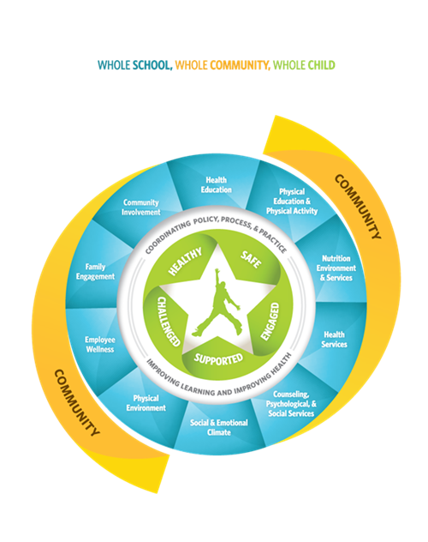

**2021-2022 FBISD SHAC GOALS**

**GOAL 1:** Actively promote and support development of Campus Wellness Committees in line with FFA (Local) to help ensure successful implementation of wellness strategies by promoting utilization of wellness resources, such as the Virtual Health School (VHS), to enhance the campus wellness environment and help achieve CIP wellness goals in accordance with FBISD District Goal 4.

**GOAL 2:** Actively promote and support development of campus Student Wellness Committees and the District Student Wellness Coalition to help advance student-led wellness initiatives to enable students to reach their full potential in accordance with FBISD Core Beliefs and the Profile of a Graduate.

**GOAL 3:** Continue actively identifying SHAC Liaisons for each campus to strengthen dialogue and facilitate continuous feedback regarding campus level wellness needs in order to provide relevant resources and support to the campus as well as support for student led wellness initiatives by Student Wellness Coalitions to enable students to reach their full potential in accordance with FBISD Core Beliefs.

**GOAL 4:** Promote incorporation of updated FFA (Operating Procedures) into current CIP strategies and objectives, to aid in the process of implementing, evaluating and improving the campus wellness environment in order to help equip students with skills for life in accordance with the Profile of a Graduate.

**GOAL 5:** Continuously evaluate FFA(Local) based on wellness concerns identified in FBISD Campus Wellness Surveys, the Pride Survey and Naviance results (and other available assessments) in order to recommend relevant resources and best practices that will equip the entire District with the life skills required to promote a whole child approach to learning, teaching and community engagement in accordance with FBISD Strategic Plan Core Beliefs and Commitments.

**GOAL 6:** Establish and develop standard SHAC communication channels throughout the District in order to share resources and best practices as well as highlight success stories with SHAC Recognition Awards to recognize campus groups, individual wellness champions and community partners who apply resources and knowledge to grow wellness on their campus, in the District, and whom further foster the development of students to exemplify the FBISD Profile of a Graduate.

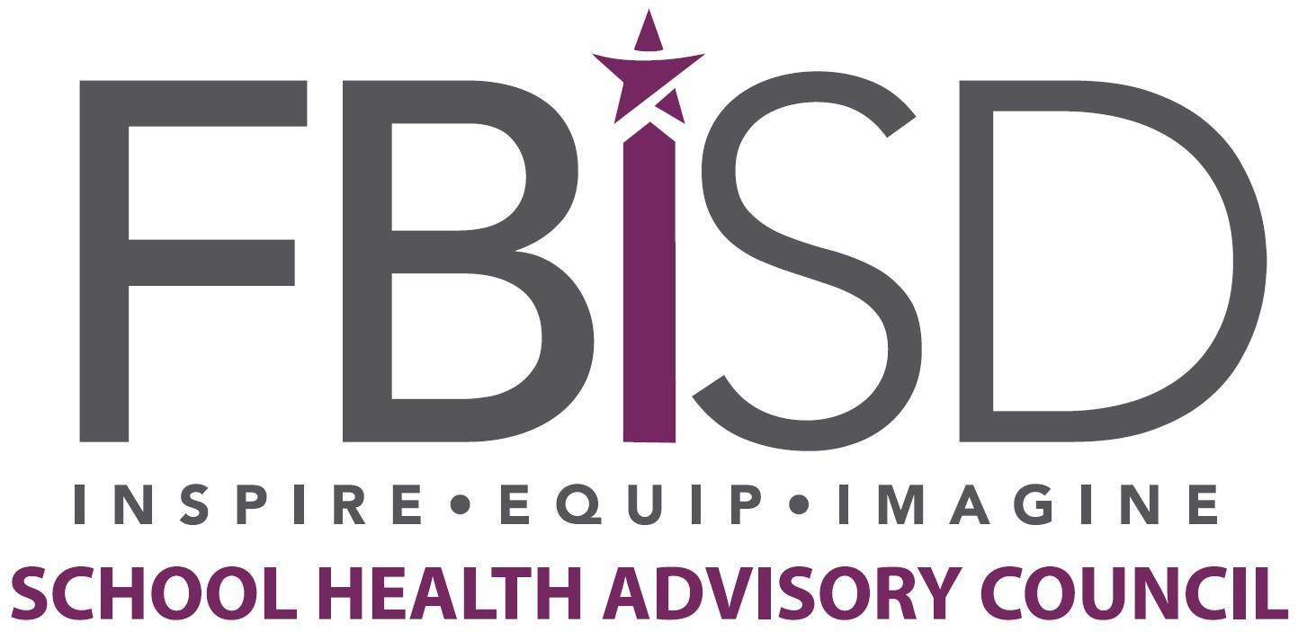

For more information, please contact Melanie Anbarci, SHAC Chair, at [chairfortbendisdshac@gmail.com](mailto:chairfortbendisdshac@gmail.com).